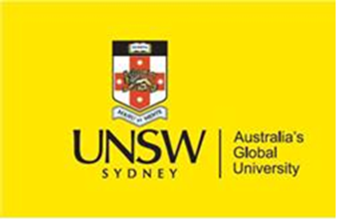

Dear Colleagues,

You are warmly invited to attend the following seminar
Title: Enabling Ambidexterity in Parallel Structures: Interface Practice
Bundles of Inter-Team Strategy-Making at NASA

Speakers: Christina Wawarta, Loizos Heracleous, Sotirios Paroutis

Date: Wednesday, 3rd March

Time: 9:00 am to 10 am

Venue: https://unsw.zoom.us/j/84626141297

Host: Gavin Schwarz

Abstract:
How can incumbent firms achieve organizational change by addressing the persistent tension between exploitation and exploration? We address this question by examining parallel structures within NASA by means of a longitudinal in-depth case study. While parallel structures are a contemporary form of organizing, strategy research in this vein has remained scarce. This is surprising as they could address the criticism associated with the three commonly proposed ambidexterity approaches. Our study reveals three bundles of interface practices that facilitate the pursuit of ambidexterity across teams within the same business unit. Further, we show how the practice set of each team changes over time due to adaptation and spillover. We theorize that such gradual change in practices may sustainably reduce the competing tensions between exploration and exploitation.

Bio:
Christina Wawarta is an Associate Fellow of the Strategy & International Business Group of the University of Warwick. Before that, she completed her PhD there in the field of Strategy-as-Practice (SAP) studying open, temporal, and cultural practices in new ways of strategizing. Two of her doctoral papers have recently been recognized with Best (PhD) Paper Awards from the SAP communities at AoM and SMS. Besides her academic career, Christina works as a Senior Strategy Manager for the Bosch Siemens Home Appliances Group, which gives her the opportunity to effectively bridge the gap between theory and practice. Christina currently also serves as a Representative-at-Large for the SAP interest groups at AoM and SMS.

Loizos Heracleous is Professor of Strategy at Warwick Business School. He earned his PhD at the University of Cambridge. His research interests revolve around organizational aspects of strategy, organization change and development, and interpretive research methods. His research has been awarded three times by the Academy of Management and has been published in 10 books and over 80 articles, in outlets that include the Academy of Management Journal, Academy of Management Review, MIS Quarterly, Strategic Management Journal, Harvard Business Review, and MIT Sloan Management Review. For more information see www.heracleous.org

Sotirios Paroutis is a Professor of strategic management and head of the strategy and international business group at the Warwick Business School, United Kingdom. He uses primarily qualitative methods to study the practices and processes organizational actors employ when dealing with strategic tensions. His work has been published in Strategic Management Journal, Organization Studies, Human Relations and Long Range Planning amongst others. For more information see www.paroutis.org

