Analyse the AGD needs of Sexual Orientation, Gender Identity and Expression (SOGIE) communities
AGD Groups  Thematic Areas | 0 -12  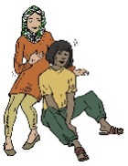 | 13 – 18  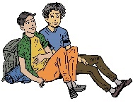 | 19 – 24  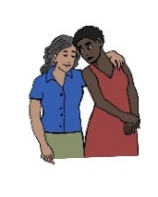 | 25-50  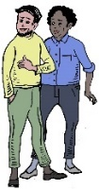 | Older than 50  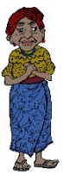 | Living with a disability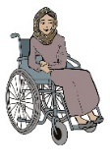
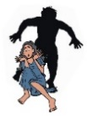  1 Incidence of SGBV | 1.1 Key issues identified: | 1.2 Key issues identified: | 1.3 Key issues identified: | 1.4 Key issues identified: | 1.5 Key issues identified: | 1.6 Key issues identified:
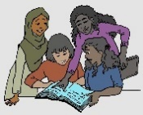  2 Barriers to access to Education | 2.1 Key issues identified: | 2.2 Key issues identified: | 2.3 Key issues identified: | 2.4 Key issues identified: | 2.5 Key issues identified: | 2.6 Key issues identified:
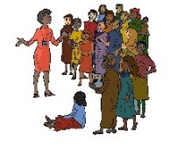  3 Responsibility & Burden Sharing incl. Refugee Participation & Capacity Building | 3.1 etc
4 Barriers to Energy & Infrastructure incl. health, shelter, WASH facilities food and water
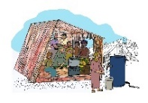
5 Strengthening Protection Capacity incl. protection from violence, GBV, discrimination, documentation and data collection
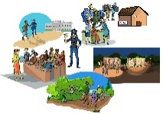
6 Jobs & Livelihoods
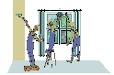
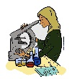

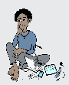
7 Barriers to Facilitating Solutions
