Analyse the AGD needs of Men and Boys from indigenous communities
AGD Groups  Barriers to: | Boys  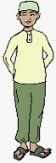  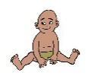  0-12 | Boys  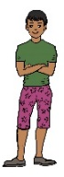  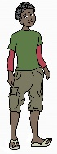  13-18 | Men  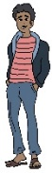  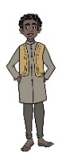  19-24 | Men  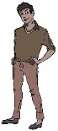  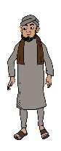  25-50 | Older  Men  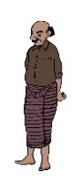 | GBTI men & boys  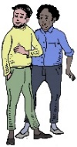 | Men & boys with a disability
1 Incidence of SGBV  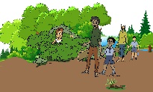 | 1.1 Key issues identified: | 1.2 Key issues identified: | 1.3 Key issues identified: | 1.4 Key issues identified: | 1.5 Key issues identified: | 1.6 Key issues identified: | 1.7 Key issues identified:
2 Barriers to Access to Education 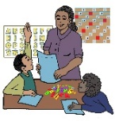 | 2.1 Key issues identified: | 2.2 Key issues identified: | 2.3 Key issues identified: | 2.4 Key issues identified: | 2.5 Key issues identified: | 2.6 Key issues identified: | 2.7 Key issues identified:
3 Responsibility & Burden Sharing incl. Refugee Participation & Capacity Building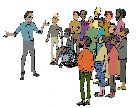 | 3.1 etc
4 Barriers to Energy & Infrastructure, incl. health, shelter, WASH facilities food and water
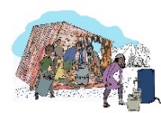
5 Strengthening Protection Capacity incl. protection from violence, GBV, discrimination, documentation and data collection
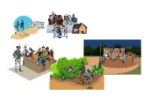
6 Jobs & Livelihoods 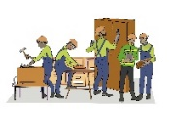
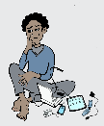
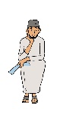

7 Barriers to Facilitating Solutions

