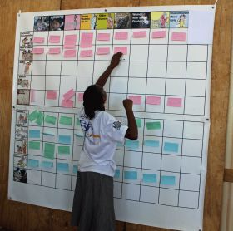
A less formal way of analysing the situation and also suitable for situations where some of the participants might be pre-literate, is the Storyboarding Exercise.

If Storyboarding is used, the six questions would be:
- What are the biggest barriers to refugee-led work that the women’s groups in xx site experience?
- What are the impacts of these barriers on the women’s groups?
- Which local stakeholders might be able to help to change this?
- What do the women need to be able to move forward and run their own organisations?
- What actions can realistically and safely be taken to support WRLOs?
- What are the hoped-for outcomes if this happens?

