Gender Roles and Cultures Exercise
This exercise explores how gender roles change over time. This happens in nearly all cultures. Sometimes the authoritarian regimes from which refugees have fled try to reverse these changes, but this causes even more resistance.

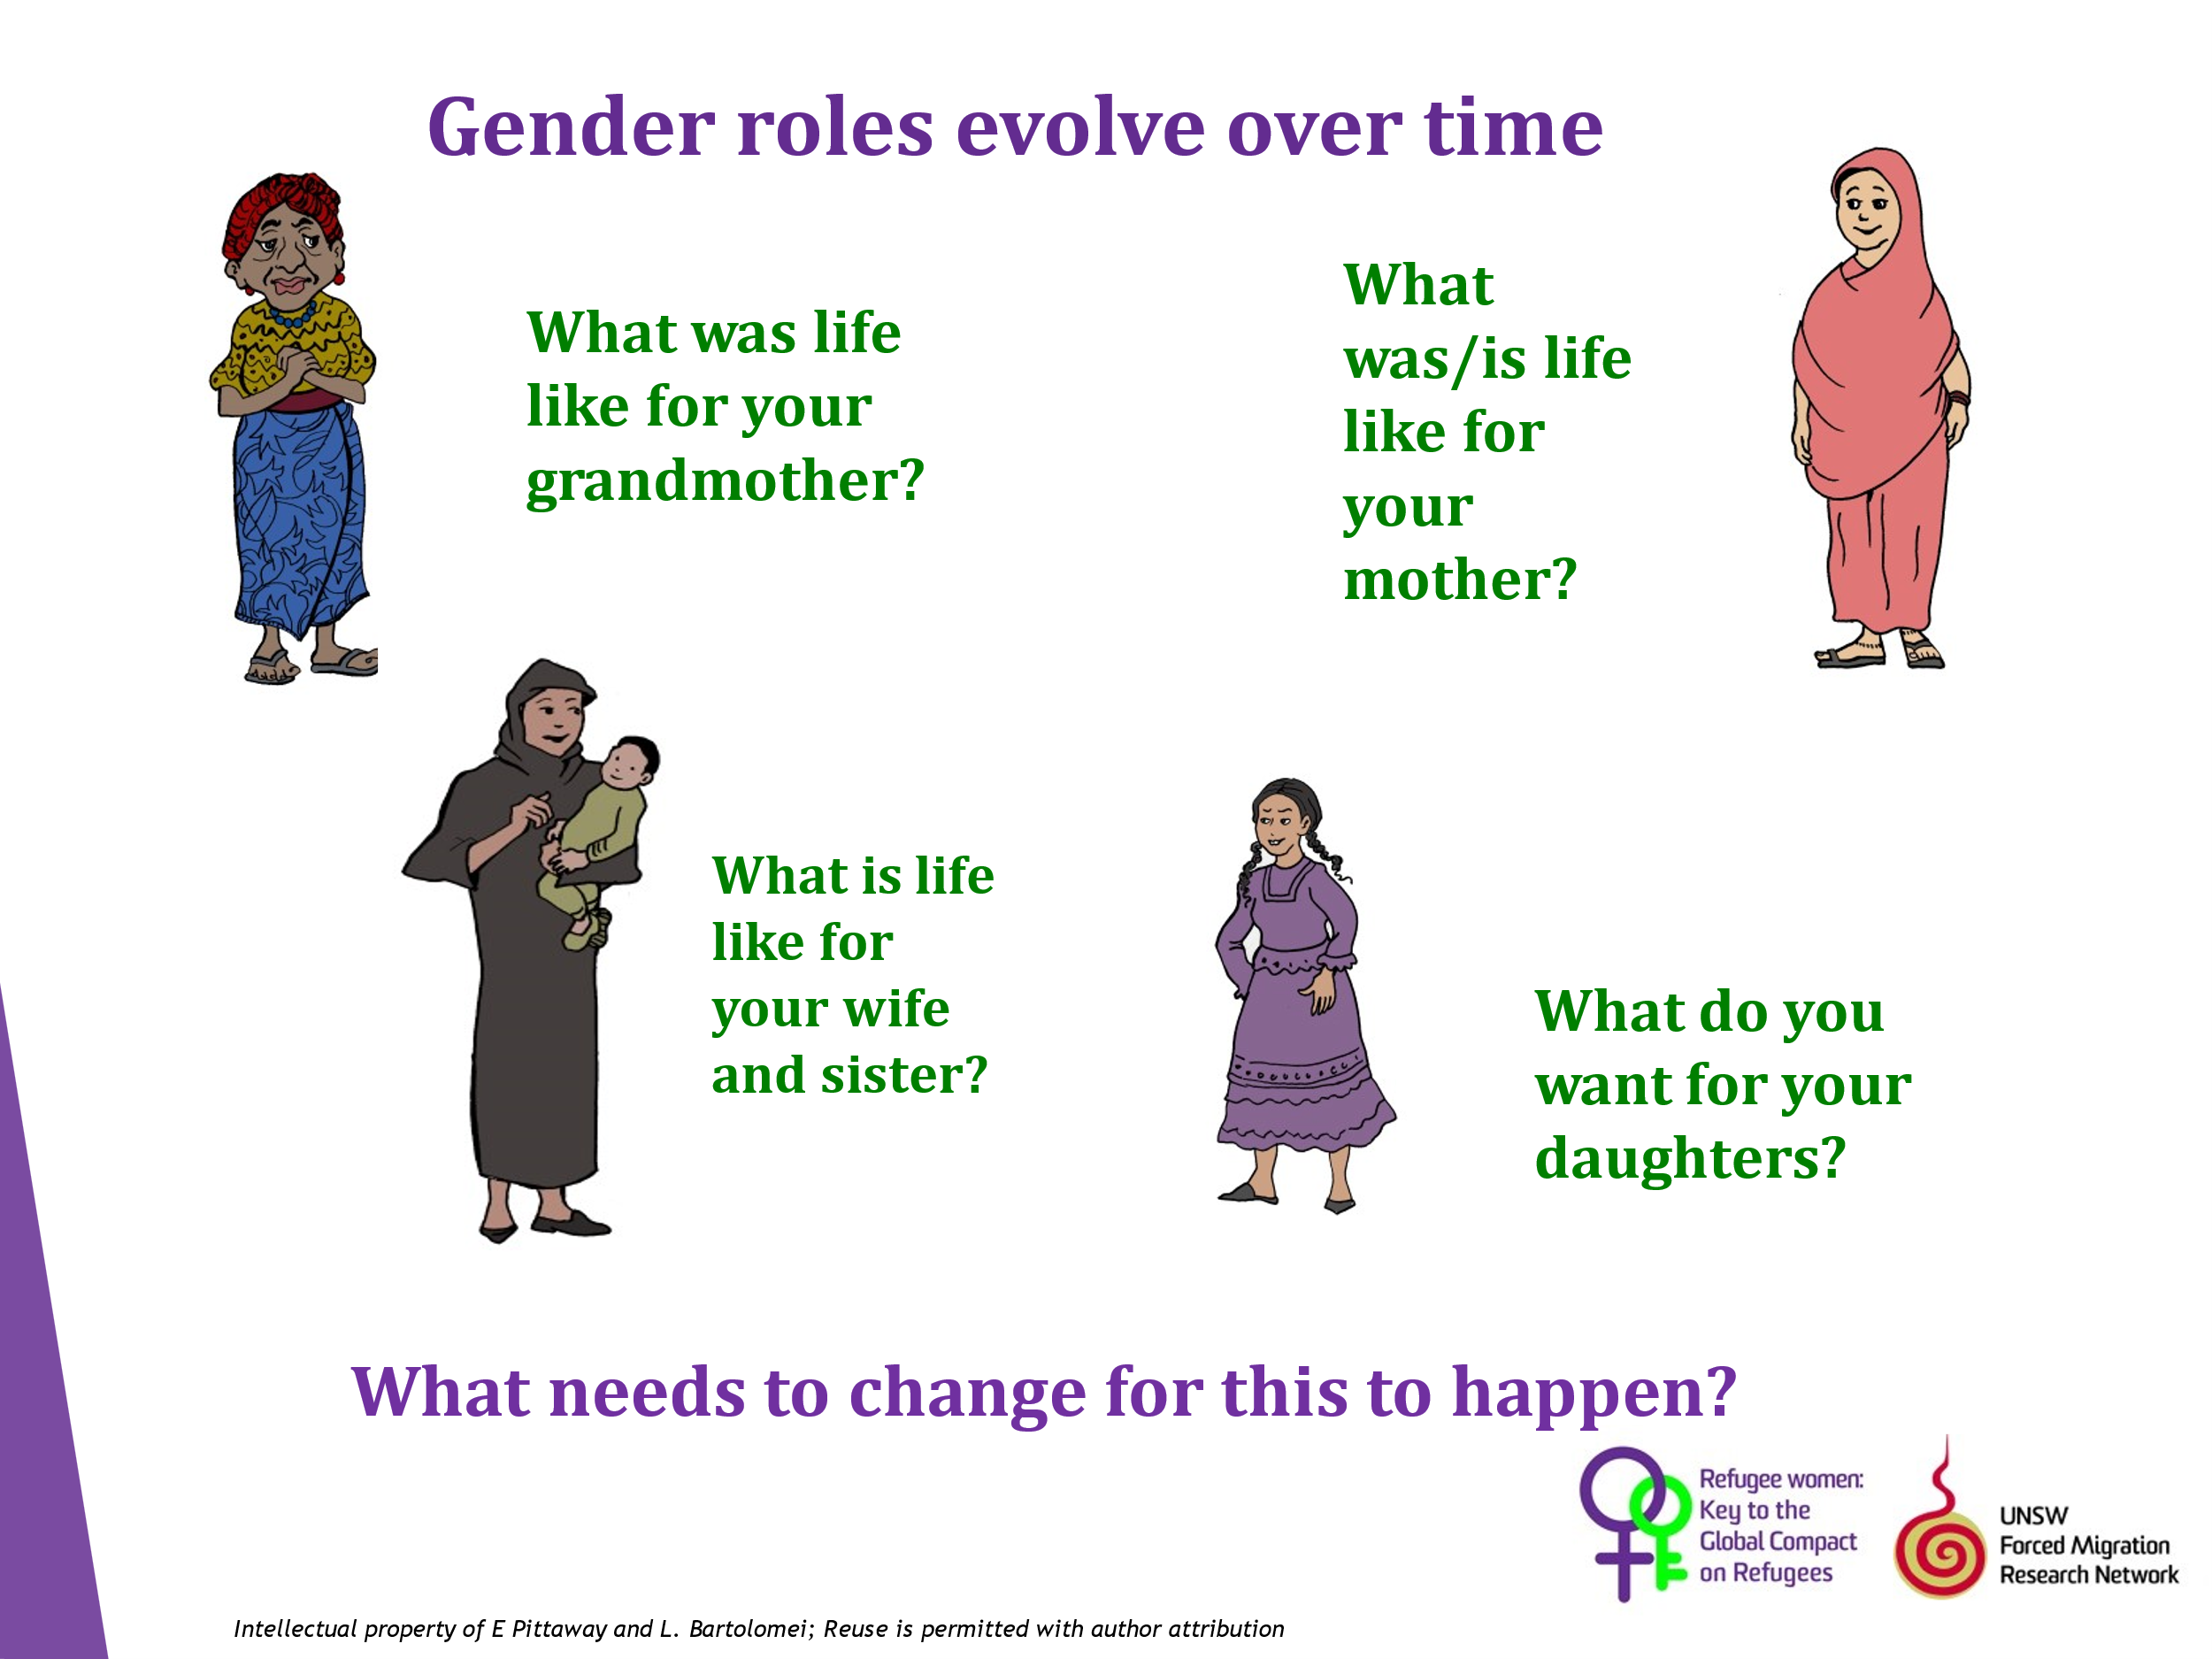

Ask the participants to write a short paragraph answering the questions on the slide, and then discuss the answers This can be done in groups if some members are unable to write). Brainstorm actions that can be taken at a local level to support gender equality and the protection of women and girls from SGBV.

