



Better mental health support for people with intellectual disability





www.arts.unsw.edu.au/sprc

Better mental health support for people with intellectual disability
Evaluation of the Residual Functions Program

Contents | Page
About this report | 3
About the program | 4
About the evaluation | 5
How we did the evaluation | 6
What the program did well for people with intellectual disability and their families | 7
What the program did well for service providers | 8
What government and providers can do next | 9
More information | 10

Report by Christiane Purcal and Rosie Pether




About this report

 |  | This report is about a program that was for people with both intellectual disability and mental health problems.
 |  | The program was called the Residual Functions Program.  We will say program for short.  The program tried to improve support for people.  For example, it helped people to manage feelings or find the right medicine.
 |  | This report talks about what the Program did well.  It also talks about what could be better.  This is called an evaluation.
About the program

 |  |  | The program helped people with intellectual disability get better mental health support.
 |  |  | The program also trained service providers to give better support to people.  The service providers were doctors, support workers and others who help people with intellectual disability.
 |  |  | The program worked in most areas of NSW.
 |  |  | The NSW Government paid for the program.
About the evaluation

 |  |  | Researchers from the Social Policy Research Centre did the evaluation of the program.  The Social Policy Research Centre is called SPRC for short.  Researchers are people who find things out by talking to people, looking at numbers or reading about other research.
 |  |  | The SPRC researchers worked with people from the Department of Developmental Disability Neuropsychiatry.  It is called 3DN for short.
     |  |  | The evaluation started in 2019.  It finished in 2021.
How we did the evaluation

 | We talked to people with intellectual disability who used the program.
 | We also talked to their families and carers.
 | And we talked to mental health services in hospitals and in clinics.
 | We looked at information about the people who used the program.
 | We looked at how much money the program cost.
What the program did well for people with intellectual disability and their families
 |  |  |  | We found that the program helped people with intellectual disability and their families feel better.
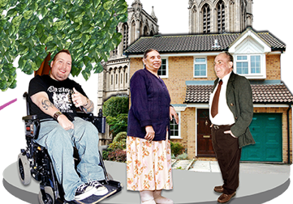 |  |  |  | People and their families found it easier to get mental health support in the community.
 |  |  |  | Some people got different medicines and different help that made them feel better.
 |  |  |  | People felt that they had more choice in how they were supported.
What the program did well for service providers
  Support | The program helped service providers give better support to people.
 | Staff training and education was better.
 | It got easier for service providers to work together.
 | Service providers could choose to offer the services that were best for each person.
 | The program was useful. It was worth spending the money on it.

What government and providers can do next

 | There are some things that government and providers can do next.
   | They can make sure that services like this are available everywhere in NSW.
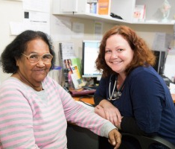 | They can make sure people with intellectual disability and mental health problems feel comfortable to use the services.
 | They can make sure that more people and families know about supports for them.

More information

 | If you want more information about the evaluation, click on the website link here.

