

Using the NDIS



The Enable In project





www.arts.unsw.edu.au/sprc
Contents | Page
About Enable In | 3
The people who used Enable In | 4
About the research | 5
How we did the research | 6
How Enable In helped people | 7
Working with service providers | 9
Tips to support people to enter NDIS | 10
Summary and further information | Back page

Report by Sandra Gendera, Karen R Fisher and
Isabella Burton-Clark



About Enable In
       | The National  Disability Insurance Scheme gives people with disability money for supports. It is NDIS for short.  Enable In helped people with disability find out how to get access to NDIS.  Enable In supported people with mental health problems and people who were homeless.  Enable In was managed by People with Disability Australia (PWDA).

The people who used Enable In
     | 400 people used Enable In.  They used it in person, by phone or in groups.  People asked Enable In about  the NDIS and other supports they needed in their life.
About the research
       | Enable In wanted to know how to give information to people who do not know about the NDIS.  Researchers at the University of NSW did the study about  Enable In.  The researchers did the study together with the Enable In team.  The Enable In team included people with disability.  People with disability gave advice to Enable In about what the project could do better.
How we did the research

 | We talked to people who used Enable In.
 | We talked to the workers in Enable In.
 | We talked to the service providers who worked with Enable In.
 | We looked at information about the people who used Enable In.
How Enable In helped people
   | People with disability said  Enable In supported them well.  They liked Enable In workers because they were  - friendly  - respectful  - understanding  - they had time.
 | Some people became confident to speak out for themselves and other people.
   |  | People got information about how to apply for NDIS support.  People also found out how to get support to  - find housing  - apply for Centrelink money  - get a driver’s licence  - see a doctor.
 |  | One person found a job  after working with the Enable In team.

Working with service providers

  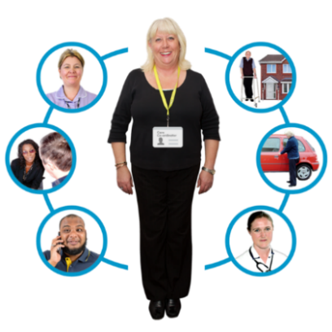   | Enable In also worked with service providers.  Enable In showed service providers how to better support people with disability  - how to explain NDIS support  - how to help people access the NDIS  - how to help people with other needs, like finding a home or getting healthy.

Tips for other services to help people get NDIS support
 | Enable In found good ways  to give people information about NDIS.
Some people first need
to trust a service.

 | Building trust takes time.  Services need to take time, so the person can get to know them.
 | Another way to gain trust is when workers do exactly what they said they would do.  Some people trust information about NDIS from a Disabled People’s Organisation.

Summary

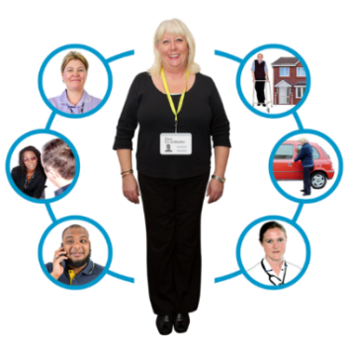 | People need support to  know about NDIS so they can get the services they need.
 | Some people first need to trust a service.  Building trust takes time.
 | For more information about the project, go to this link  - Enable In – People with Disability Australia (pwd.org.au) Enable In action research | Social Policy Research Centre – UNSW Sydney

