This document will discuss mental health. If this content makes you upset please reach out for support.
Easy Read

Intellectual Disability and Mental Health Strategy Summary
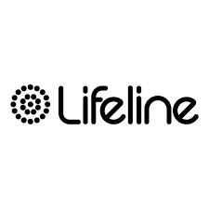       | If you need support with your mental health you can call  - Lifeline 13 11 14  - NSW Mental Health Line 1800 011 511  - Kids Helpline 1800 55 1800  - 13 YARN for Aboriginal and Torres Strait Islander people on 13 92 76.
NSW Health wants to better support people with intellectual disability.

 | People with intellectual disability might also have mental health problems.
 | A mental health problem is when feelings start to bother you.
 | A mental health problem can also be when you do not feel in control of your feelings.
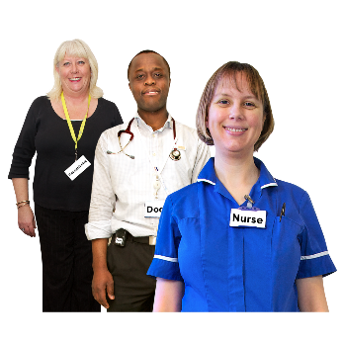 | Mental health services are for people with a mental health problem.
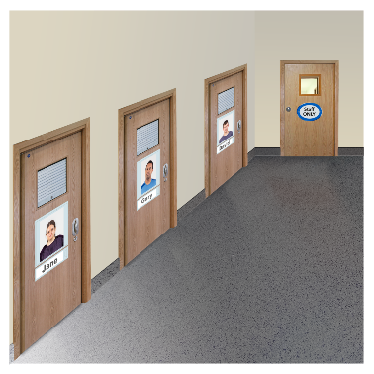 | Some mental health services are in a hospital ward.
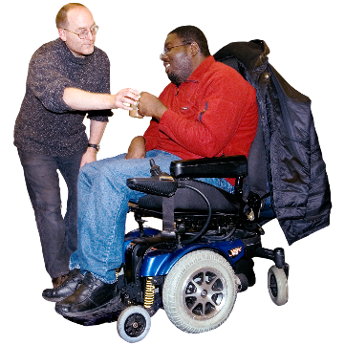 | Mental health services can:  - Support you when your doctor is unable to help you feel better  - Support you talk about your feelings  - Give you medicine.
How does NSW Health plan to do this?
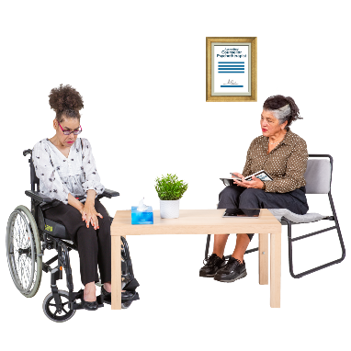 | NSW Health is writing a plan to tell health workers, people with intellectual disability and their families how NSW Health will make mental health services easier to use and safer for people with disability.  This is called a Strategy.
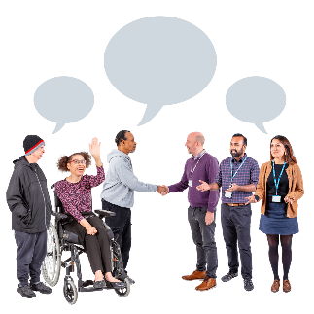 | NSW Health wants to do this by:  - Listening to people with intellectual disability  - Making services easier to use  - Training staff to give better care  - Working together with families and carers.
 | The strategy is based on 4 principles  A principle is an idea that helps people decide how to act in different settings.  NSW Health spoke to people who chose these principles  - Person – centred: Making sure care that fits your needs is easy to access  - Collaborative: Helping mental health, health and disability services to services work better together  - Innovative: Finding new ways to support people with disability  - Inclusive: Making sure everyone is welcome when they need support from mental health services.
The strategy also has 5 key themes.

A theme helps people to understand how to turn a principle into an action.

NSW Health spoke to people who chose these themes

Working Together
Different services need to work as a team to support people with intellectual disability and their families. This helps everyone get the care they need.

Better Data, Better Outcomes
Good information helps us plan better mental health services and make smarter decisions.

Learning Together
Training and learning for health workers, people with disability and families helps make services more inclusive and work better for everyone.

Better Everyday Care
NSW Health wants to give safe, high-quality care that focuses on what patients and families need.

Removing Barriers, Enabling Care
Making mental health services easier to find and use helps people live better lives—and can save money too.

 | If the strategy works, you will  - Get care that suits you  - Be asked about your wants and needs  - Feel safe at hospitals and mental health services  - Be able to speak up and be heard.
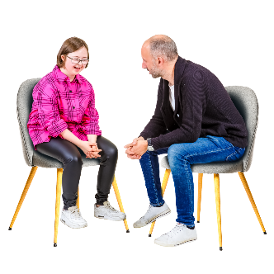 | For example, it will be easier to tell a mental health worker  - When an idea or type of care doesn’t work  - When you don’t feel comfortable  - When you don’t agree with the mental health worker or doctor.
 | NSW Health is asking people with intellectual disability for their ideas the strategy.
 | If you want to tell NSW Health about your ideas you can  - Come to a group and talk about it  - Use a drawing or artwork to show your ideas  - Record a voice message or video  - Visit a website.
 | NSW Health will use the ideas to make the strategy better.
 | NSW Health will release the strategy in 2026.
 | More information
 | If you have questions or what more information about the strategy you can  - Call us on (02) 9461 7272  - Email us at  MOH-MHB-DSP@health.nsw.gov.au  - Go to our website at: Intellectual Disability Mental Health Strategy Consultation 2025
 | The images in this information are from Photosymbols. You need to contact us if you want to use any of the photos.

