Intellectual Disability Mental Health Strategy – NSW Health

NSW Ministry of Health
Publication Date: Pending

Table of Contents
Content warning 3
Definitions 5
Introduction 6
People with intellectual disability and mental health concerns face barriers in trying to access mental health services 7
Supporting People with Intellectual Disability and Mental Health Needs in NSW 9
Principles of the Intellectual Disability Mental Health Strategy 10
Person Centred 11
Collaborative 11
Innovative 12
Inclusive 12
Themes of the Intellectual Disability Mental Health Strategy 13
Working Together 14
Better Data, Better Outcomes 16
Learning Together 17
Better Everyday Care 18
Removing Barriers, Enabling Care 19
Strategy Development 20
References 21

This strategy was developed with input from people with intellectual disability, including members of the Council for Intellectual Disability (CID) and the National Centre of Excellence in Intellectual Disability Health (NCEIDH). NSW Health thanks Ben Pilipowski – Inclusion Projects Worker (CID), Raylene Griffiths – Driving Change Project Worker (CID/ NCEIDH), Tahli Hind – Project Officer (NCEIDH), Ricky Kremer – Lived Inclusion Lead (NDEIDH) and members of the NCEIDH First Nations Committee for sharing their knowledge and experiences. Their voices helped shape the words and ideas that will guide future practice.

Content warning
The Intellectual Disability Mental Health Strategy contains information that may be distressing to some readers. It includes information about the experiences of people with an Intellectual Disability and mental ill health, their families and carers, and the barriers they face. The following free services are available to support you if you need help:
NSW Mental Health Line
The 1800 011 511 Mental Health Line is NSW Health's 24/7 statewide phone service which links people with NSW Health mental health services. It is a free service.
It is staffed by trained mental health professionals who:
- offer mental health advice
- complete a brief assessment
- make recommendations for appropriate care, including referral to NSW Health mental health services.
The mental health professional will ask the caller questions to understand the person’s needs and recommend appropriate services.

Transcultural Mental Health Line
The Transcultural Mental Health Line is a telephone service that supports people who live in NSW and who are from culturally and linguistically diverse communities.
- The Line is open from Monday to Friday between 9:00 am and 4:30 pm.
- Call the Transcultural Mental Health Line on 1800 648 911.
Lifeline Crisis Support
A confidential service providing support when someone is feeling overwhelmed, having difficulty coping or thinking about suicide.
- Speak to a crisis support worker by telephone on 13 11 14, 24 hours a day, 7 days a week.
- Chat online 24 hours a day, 7 days a week.
- Website: Lifeline Crisis Support.
Kids Help Line
Kids Helpline is Australia’s only free, private and confidential 24/7 phone and online counselling service for young people aged 5 to 25. The service is available 24 hours a day from anywhere in Australia.
- Speak to a counsellor by telephone on 1800 55 1800, 24 hours a day, 7 days a week.
- Chat online 24 hours a day, 7 days a week.
- Website: Kids Help Line – Get Help!
13 YARN
A free and confidential one to one crisis support service available for Aboriginal and Torres Strait Islander people.
- Support from Aboriginal and Torres Strait Islander crisis counsellors is available at 13YARN (13 92 76)
visiting: 13 YARN.

Definitions
The Intellectual Disability Mental Health Strategy has used language such as people or person with Intellectual Disability and mental illness, mental health concern. They are defined as:
- Intellectual disability is a type of developmental disability. It means a person has trouble with cognitive (thinking) skills such as problem solving, planning, and learning new information, and may need support to complete everyday tasks. They might also have difficulties with communication, social interactions, and doing daily activities on their own​ ^{[4]}​.
- Mental Illness: A mental illness is a health problem that significantly affects how a person feels, thinks, behaves, and interacts with other people. It is diagnosed according to standardised criteria. The term mental disorder is also used to refer to these health problems. [1]
- A mental health concern is when someone feels that their thoughts, feelings, or behaviours are not quite right and might be affecting their life in a difficult way. It could mean:
  - Feeling very sad, worried, or angry for a long time
  - Having trouble sleeping, eating, or doing everyday things
  - Feeling confused or scared and not knowing why
  - Not enjoying things, you used to like

A mental health concern is not the same for everyone. It doesn’t always mean there is a mental illness. It just means something might be going on that needs care, support, or a chat with someone you trust.

Some terms have different meanings for different people. It is important to be aware of these differences. For example, the term social and emotional wellbeing (SEWB) is used by many Aboriginal and Torres Strait Islander people to describe the social, emotional, spiritual and cultural wellbeing of a person. It is important to be aware of the cultural background of the person, family or community and to seek advice from members of culturally and linguistically diverse (CALD) communities or Aboriginal and Torres Strait Islander people if possible, so that terms can be used appropriately.

Introduction
The NSW Ministry of Health wants to improve services for people living with both intellectual disability and mental health concerns. People with intellectual disability experience mental illness more often than people without disability yet encounter services that do not meet their mental health needs. NSW Health, through Future Health, describes a vision where all individuals, regardless of cognitive ability, receive equitable, person-centred care. NSW Health mental health services can play a leading role in shaping a health system that is inclusive, compassionate, and responsive to diverse needs. [2]
This change is achievable. The NSW Health Disability Inclusion Action Plan (updated plan to be released in 2026) commits to enhancing staff capability, adapting communication methods, and improving services for people with disability, including mental health services. Through collaboration and facilitating the leadership of people with intellectual disability, carers, and advocacy organisations, NSW can co-design services, systems and outcomes that reflect the needs and values of all consumers in contact with mental health services. [3]
Commitment to people with intellectual disability and mental health concerns reflects the CORE values of NSW Health- compassion, openness, respect and empowerment. Improving health outcomes for people with intellectual disability is a public health priority. Alongside clear frameworks and guidance, NSW Health’s mental health services can take practical steps to build a system where every person is supported to live well, participate fully, and receive compassionate care that meets their individual needs.

People with intellectual disability and mental health concerns face barriers in trying to access mental health services
In New South Wales, about 1.8% of the population has an intellectual disability. [4] About 76% of people with intellectual disability have had a mental health concern, compared to 38% of the general population. Around 16% have had a serious mental illness. A mental illness is a health problem that significantly affects how a person feels, thinks, behaves, and interacts with other people. It is diagnosed according to standardised criteria. [5]
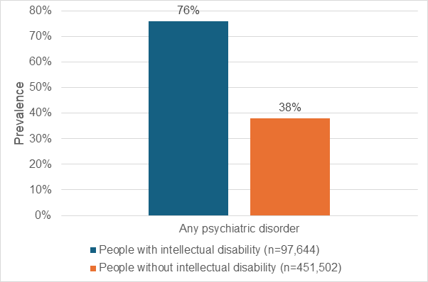

Arnold SR, Huang Y, Srasuebkul P, Cvejic RC, Michalski SC, Trollor JN. Prevalence of psychiatric conditions in people with intellectual disability: A record linkage study in New South Wales, Australia. Aust N Z J Psychiatry. 2025;59(5):433-447 [6]
People with intellectual disability can find it hard to access to good care from health professionals and services for their mental health [7]. Some of the things that make it hard for people with intellectual disability to access mental health care include:
- People with intellectual disability may find it hard to access mental health care as they might not recognise changes in their thoughts or feelings that suggest they need support.
- Availability of appropriate and adapted services
- Referral processes, service criteria and complex systems that exclude people with intellectual disability
- Health staff that are confident and equipped to meet the mental health needs of people with intellectual disability
- Diagnostic overshadowing where signs of a mental health concern are instead viewed as part of challenging behaviours related to intellectual disability.
- Mental health concerns might present differently
- Social determinants which are the conditions in which people are born, grow up, live, work, and age in. These conditions affect a person’s health, wellbeing, and quality of life. Examples include, where a person may live, their job and income, education, social support and access to services.

People with intellectual disability use public mental health services in New South Wales more often than the general population [8]. They make up 6% of all people who use NSW Health mental health services, and 12% of the mental health budget is spent on their care [8].
This shows that people with intellectual disability are getting support—but there’s still work to do. Many face challenges like more frequent hospital admissions, longer stays, and needing more intensive care in the community. Often, the care they receive doesn’t fully meet their needs, which can lead to repeated emergency visits and poor follow-up care [7].

Supporting People with Intellectual Disability and Mental Health Needs in NSW

People with intellectual disability in NSW face significant barriers to accessing appropriate mental health care. The service environment has become increasingly complex. People with intellectual disability often need support across health, disability, education, and justice sectors, but navigating these systems is difficult. This complexity leads to service gaps and poorer outcomes for individuals and their families.
The National Roadmap for Improving the Health of People with Intellectual Disability, released in 2021, provides direction for addressing these inequities. It was developed through extensive consultation with people with intellectual disability, families, carers, and professionals. The Roadmap sets out a vision for a health system where people with intellectual disability are valued, respected, and have access to high-quality, timely, and comprehensive care
Key priorities include:
- Better models of care tailored to the needs of people with intellectual disability.
- Support for families and carers, recognising their essential role.
- Training for health professionals to improve inclusive and effective care.
- Improved oral health, preventive care, and emergency preparedness.
- Better data and research to monitor outcomes and drive
The Royal Commission into Violence, Abuse, Neglect and Exploitation of People with Disability (DRC) had 222 recommendations on how to improve laws, policies, structures and practices to ensure a more inclusive and just society that supports the independence of people with disability and their right to live free from violence, abuse, neglect and exploitation. The NSW Government response to the DRC affirmed the NSW Governments commitments to delivering safe and inclusive services for people with disability.

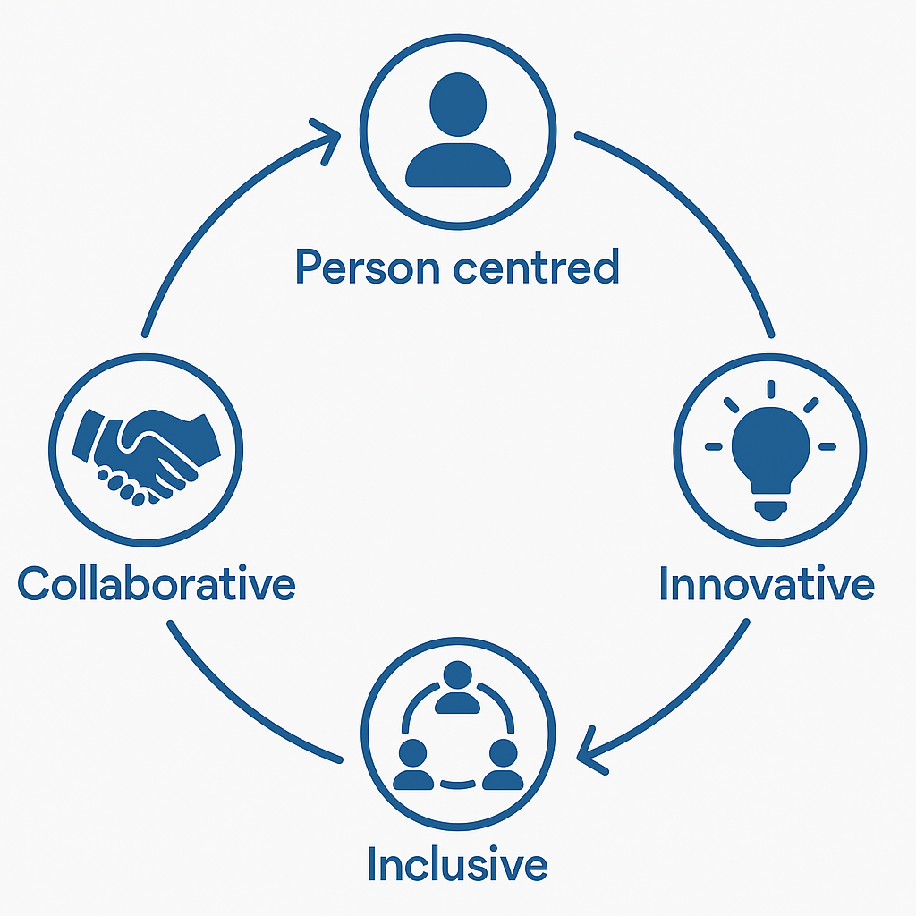
Principles of the Intellectual Disability Mental Health Strategy

The Intellectual Disability Mental Health Strategy is guided by four key ideas, called Principles. These principles are meant to shape everything in the Strategy. They are:

Person-centred – focused on the individual’s needs and strengths
Collaborative – working together across services and with communities
Innovative – finding new and better ways to support people
Inclusive – making sure everyone is welcomed and involved

Person Centred
This means putting the person at the heart of their care. It is about understanding their unique needs, strengths, and preferences—not just focusing on their symptoms. Instead of making decisions for them, we plan care with them. This approach started in the disability sector and is now used across healthcare in Australia.
For NSW Health staff, person-centred care means treating people as active partners in their health. It’s especially important for people with intellectual disability or mental health challenges, where their voice can often be overlooked.
As Ben said, “It’s important to use the social model of care… not just give out medication.”
Tahli shared that person centred care meant “letting the person make their own decision without influence.”
Ricky appreciated when a specialist “spoke to me directly and explained things in a way I could understand.”
Raylene summed it up: “Include the person with intellectual disability and give them the best care… let them be heard.”

Collaborative
Collaboration means different services working together to support the person. It includes the person with lived experience, their carers, families, and kinship groups in planning and reviewing care. This helps personalise care and leads to better outcomes.
For NSW Health staff, collaboration means breaking down silos and working as a team. It’s especially important for people with intellectual disability, who often see many providers. Ricky noted the value of “doctors working together with mental health professionals… so that everyone is on the same page.” Ben added that professionals should “work with me rather than just trying to force people… to do things,”
Examples of collaborative care include:
- Adjusting communication to suit the person’s needs
- Providing easy-to-read information
- Using technology to share information
- Working together to reduce the use of practices like restraint or seclusion
- Encouraging everyone to share their views safely
Tahli’s example of working with Anaïs (Workplace Support Officer, National Centre of Excellence in Intellectual Disability Health) to complete feedback illustrates collaboration in action: “Anaïs and I doing this together so I can think openly and clearly.” This teamwork not only supports better outcomes but also empowers individuals to participate fully in their care.

Innovative
Innovation means finding new ways to improve care. This could be using technology, trying new approaches, or solving problems creatively. It helps make care more flexible and suited to each person’s needs.
In Australia, innovative models of care often involve creative problem-solving, flexible service delivery, and the integration of digital tools to meet diverse patient needs.
For NSW Health staff, working innovatively is crucial to adapting to the evolving needs of patients. Every person has different needs, and innovation helps staff to personalise care, enhance accessibility, and tailor engagement. Ben emphasised that “every person… is going to have different needs,” and praised specialists who creatively helped him remember his medication schedule.
Tahli and Anaïs demonstrated innovation through their creation of a “Brain Break Corner” in their workplaces, featuring mindfulness tools and fidget toys. “We’re getting great feedback and people are wanting more,” Tahli shared, showing how small, creative changes can have a big impact. Ricky also highlighted the importance of flexibility: “Being able to adjust the way you work in order to get the best outcomes.”

Inclusive
Being inclusive means making sure everyone feels welcome, respected, valued and able to take part. It’s about recognising different needs and making sure people have the tools and support to be involved.
For NSW Health staff, inclusiveness is the foundation of equitable care. Ben explains, “The whole point of being inclusive is that everyone is treated equally and with respect. It is a human right.” Ricky echoed this, noting the importance of “not making judgement about patient’s situation.”
Tahli shared several inclusive strategies, such as using visual aids and reminders to support her mental health. “My psychologist tells me things and repeats it to me slowly so I can take notes,” she explained. Her favourite quote, “what’s right for one person, may not be right for another,” perfectly captures the essence of inclusive care.

Themes of the Intellectual Disability Mental Health Strategy
The Intellectual Disability Mental Health Strategy has been developed under five key areas. These areas have been named by members of our lived experience working group to reflect the impact that each area has on their lives.

- Working Together: Different services need to work as a team to give people with intellectual disability—and those who support them—the care they need.
- Better Data, Better Outcomes: Good data helps us design better mental health services and policies.
- Learning Together: Training and education for health workers, people with disability and their families is key to making services more inclusive and effective.
- Better Everyday Care: NSW Health aims to give safe, high-quality care that puts patients and families at the centre.
- Removing Barriers, Enabling Care: Making mental health services easier to access improves lives and saves money.

Working Together
People with intellectual disability and their families need coordinated, barrier-free services across sectors that are guided by their goals and preferences. This may require the complex coordination of a range of services across traditional service silos.
Care that effectively bridges these silos and gaps between providers creates outcomes that are better for the person, their family, and helps to prevent the need for acute or emergency care. [8]

The NSW Health Framework for Integrating Care identifies nine building blocks that are needed for integrated care to work well:
- Engagement
- Partnerships
- Leadership
- Culture
- Governance
- Funding
- Capability
- Technology
- Information
Outcomes
Outcome 1: People with intellectual disability and their families are actively involved in care decisions through inclusive, respectful communication and personalised care planning.
Outcome 2: Service leaders and staff foster collaboration and innovation by modelling inclusive behaviours and supporting coordinated, person-centred care across settings.
Outcome 3: System-level structures—including funding, policy, and accountability—enable sustainable, integrated care that removes barriers and prioritises high-impact, preventive approaches.
If this strategy is successfully achieving these outcomes we may see:
Person with Intellectual Disability: When you go to hospital or access a community mental health service the staff member will talk to you first. The staff member will ask you about your preferences, using ways of communicating that suit you. They will share information in easy read if needed.
NSW Health Clinician: Clinicians collaborate across roles, services, and sectors - including health and disability - to provide integrated, person-centred care. This allows clinicians to feel empowered and valued in a system that fosters innovation, shared decision-making, and reflective practice.
NSW Health: NSW Health enables integrated care by aligning policies, funding, and systems. Services work together to provide coordinated, person-centred care.

Better Data, Better Outcomes
Good data is essential for designing, delivering, and improving mental health services for people with intellectual disability. It also helps tackle the serious inequalities they face in accessing care.

Inclusive data systems should:
Help identify people with intellectual disability
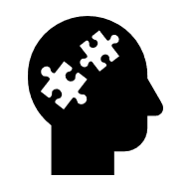
Track their health journeys


Measure how well services and treatments are working

However, current data collection systems have gaps. NSW Health's routine data collections often do not capture intellectual disability in a consistent or accurate way. Standard clinical documentation tools are not designed or tested to reflect the specific needs or experiences of people with intellectual disability.
Outcomes

Outcome 1: People with intellectual disability are accurately identified in NSW mental health and health data systems.

Outcome 2: Reasonable adjustments and person-centred information are consistently recorded to support individualised care.

Outcome 3: Data about people with intellectual disability is used to drive research, planning, service improvement, and accountability.

If this strategy is successfully achieving these outcomes we may see:
Person with Intellectual Disability: When you go to hospital or access a community mental health service a staff member will record your intellectual disability in the health care system with your permission. This will allow for future appointments to be adjusted to your care needs.
NSW Health Clinician: Clinicians can make more informed decisions with access to accurate, up-to-date data that reflects the needs and experiences of people with intellectual disability. This allows Clinicians to feel encouraged to use reasonable adjustments with their clients.
NSW Health: NSW Health can design better services, policies and programs using data that highlights what works, where gaps exist, and how to target resources.

Learning Together

Research shows that many health professionals lack experience and confidence in meeting the mental health needs of people with intellectual disability.

This means that people move between services without access to the right types of care. If we help people build the right skills, we can make it much easier for people with intellectual disability to get better mental health care.
Building capacity in Intellectual Disability Mental Health care means developing skills, knowledge and resources across the health system to better support people with intellectual disability who have co-occurring mental health concerns. It includes training staff in how to work with, communicate and support people with disability and their families, as well as sharing specialist mental health knowledge about the needs of people with intellectual disability.
By working together, we can make the training, resources and support needed available, so that staff feel confident and capable, leading to a system where people with intellectual disability can access appropriate mental health services that meet their needs.
Outcomes
Outcome 1: Staff will help create a more inclusive and informed mental health system by continuing to engage in education and training focused on intellectual disability.

Outcome 2: NSW Health’s capacity-building initiatives are enriched by authentic, real-world content that reflect lived experiences and practical application.

If this strategy is successfully achieving these outcomes we may see:
Person with Intellectual Disability: When you go to hospital or access a community mental health service a staff member be trained to understand and support your unique needs. This will help you feel safer and more included in mental health settings where communication is adapted.
NSW Health Clinician: Clinicians feel more confident and capable in supporting people with intellectual disability through targeted training and access to practical resources. Training will include real-world knowledge and inclusive practices learned through capacity-building initiatives.
NSW Health: NSW Health can build long-term staff capability by investing in inclusive education, leadership, and collaboration across regional, metropolitan, and custodial settings.

Better Everyday Care
NSW Health is dedicated to giving people in New South Wales the best possible health care. This obligation is guided by its core values: working together, being honest, treating everyone with respect, and helping people take control of their health.
Why Early Support Matters
Getting help early is key to good health care—especially for people with intellectual disability, who are more likely to face mental health challenges than others. The more serious the disability, the higher the risk of mental illness. That’s why it’s so important to spot health problems early and act quickly. Early support can help people avoid pain, long-term damage, or even early death.
Involving People in Their Own Care
When people with intellectual disability and mental illness are involved in decisions about their health, it makes a big difference. Studies show that people who take part in their care feel more satisfied, understand their health better, and are more likely to follow through with treatment. They also feel less worried, avoid unnecessary tests, and often have better health outcomes overall.

Safe and Personalised Support
To make health care safe for people with intellectual disability, services must work together in a well-organised way. This means recognising their specific needs and providing care that is both supportive and tailored to them, guided by strong standards and dedicated services.
Outcomes
Outcome 1: People with Intellectual Disability in contact with NSW Health delivered mental health services are supported to meet their full range of health care needs, including preventative, primary and specialist care.
Outcome 2: NSW Health staff support people with intellectual disability to lead and make decisions about their mental health care
Outcome 3: NSW Health staff support the delivery of safe and effective care through access to training and capacity building activities.

If this strategy is successfully achieving these outcomes we may see:
Person with Intellectual Disability: When you go to hospital or access a community mental health service you will receive safe, personalised care that meets all your health needs—mental, physical, and preventive. You will be supported to lead decisions about your care this will be regardless of where you live and how you access services.
NSW Health Clinician: Clinicians feel empowered to engage in Clinician supported shared decision-making practiced with people with Intellectual Disability. They can help people with Intellectual Disability to understand their options and take control of their mental health journey.
NSW Health: NSW Health aims to deliver more proactive and integrated care, ensuring early identification and timely support for people with intellectual disability and mental illness.

Removing Barriers, Enabling Care
NSW Health is committed to delivering services that are non-discriminatory, equitable, and efficient, in line with the Anti-Discrimination Act. This includes ensuring that people with co-occurring Intellectual Disability and Mental Health concerns can access timely, inclusive care and fully participate in their communities. Mental health services play a key role in removing barriers to access and promoting fair treatment for all.
People with intellectual disability commonly experience trauma, stigma, loneliness and social isolation, lower socioeconomic status and impoverished living situations which contribute to poorer mental health outcomes.
Person Led Care
When working with people with an intellectual disability, mental health interventions and care planning need to take a person-centred approach and family focused approach that considers the impact and influence of co-occurring conditions. It is important that interventions provided take into consideration and complement those prescribed for the person by other health and disability professionals. Mental health care that is not provided in a person-centred way can increase contact with the mental health system, reinforce stigma, escalate or cause unnecessary negative behaviours and lead to further traumatisation a person. Informing planning, workforce, service design, and policy.
Outcomes
Outcome 1: People with intellectual disability are to be provided reasonable adjustments to access care.

Outcome 2: Modified environments where mental health care is delivered are offered where possible for a person with Intellectual Disability.

Outcome 3: Improving access for priority populations such as regional and remote citizens, Aboriginal people, women and LGBTQ+
If this strategy is successfully achieving these outcomes we may see:
Person with Intellectual Disability: When you go to hospital or access a community mental health service you will feel less stigma and more inclusion as these services will actively work to reduce discrimination and promote person-led care.
NSW Health Clinician: Clinicians feel supported to engage in actions that better remove barriers to mental health care. They may do this by applying inclusive practices and making reasonable adjustments for people with intellectual disability.
NSW Health: NSW Health strengthens person-led care by supporting workforce development including staff training and lived experience employment, cross-sector collaboration, and trauma-informed practices.

Strategy Development

The NSW Intellectual Disability Mental Health (IDMH) Strategy was created to improve mental health services for people with intellectual disability. From the beginning, the strategy was shaped by the voices and leadership of people with lived experience.
The NSW Ministry of Health worked with researchers, families, carers, service providers, and people with intellectual disability to understand what was working, what wasn’t, and what needed to change. A drafting group, including people with intellectual disability and partners from the National Centre of Excellence in Intellectual Disability Health and NSW Council for Intellectual Disability, helped guide the process. Consultation started in 2022 with people with disability and continued through 2025. This was supported by consultation and support of the NSW Health IDMH Network, who provided structure, strategy design and guidance through the 2024 and 2025 IDMH Forums.
Consultations were held across NSW using Easy Read materials, supported participation, and co-design workshops to make sure everyone could be involved.
People shared their stories and ideas. They said services needed to be easier to access, more welcoming, and better at listening. They wanted staff to be trained to understand their needs, and for services to work together—not in silos. They also wanted to be part of the solution—not just as clients, but as leaders, peer workers, and advisors.
The strategy was built around these messages. It includes actions to support peer roles, improve communication, and make services more inclusive and culturally safe. A communications plan was also developed to keep people informed and involved, using accessible formats and clear messages.
This strategy is not just a document; It is a commitment to doing things differently. It recognises that people with intellectual disability are experts in their own lives and deserve to lead the way in shaping the services they use.

References

[1] |  | NSW Health, “What is mental illness?,” NSW Health, 20 January 2020. [Online]. Available: https://www.health.nsw.gov.au/mentalhealth/psychosocial/foundations/Pages/mental-illness.aspx. [Accessed 26 August 2025].
[2] |  | NSW Health , “Future Health: Guiding the next decade of care in NSW,” NSW Health, Sydney, 2022-2032.
[3] |  | NSW Government , “NSW Disability Inclusion Plan,” NSW Government , Sydney, 2021.
[4] |  | World Health Organization , “Mental disorders,” World Health Organization, 8 June 2022. [Online]. Available: https://www.who.int/news-room/fact-sheets/detail/mental-disorders. [Accessed 10 March 2025].
[5] |  | NSW Government , “What is mental illness?,” NSW Health, 20 January 2020. [Online]. Available: https://www.health.nsw.gov.au/mentalhealth/psychosocial/foundations/Pages/mental-illness.aspx#:~:text=%E2%80%9CA%20mental%20illness%20is%20a%20health%20problem%20that,to%20these%20health%20problems.%E2%80%9D%20%28Australia%20Department%20of%20Health%29. [Accessed 31 July 2025].
[6] |  | S. R. Arnold , Y. Huang , P. Srasuebkul, R. R. C. Cvejic , S. C. Michalski and J. N. Trollor , “Prevalence of psychiatric conditions in people with intellectual disability: A record linkage study in New South Wales, Australia,” The Australian & New Zealand Journal of Psychiatry (ANZJP) , 2025.
[7] |  | E. L. Whittle, K. R. Fisher, S. Reppermund, R. Lenroot and J. Trollor, “Barriers and Enablers to Accessing Mental Health Services For People with Intellectual Disability: A Scoping Review,” Journal of Mental Health Research in Intellectual Disabilities, vol. 11, no. 1, pp. 69-102, 2018.
[8] |  |  | P. S. J. N. T. Janelle C Weise, “Potentially preventable hospitalisations of people with,” The Medical Journal of Australia , vol. 215, no. 1, pp. 31-36, 2021.
[10] |  |  | Department of Health., “National Roadmap for Improving the Health of People with Intellectual Disability,” Commonwealth of Australia, 2021.
[11] |  |  | Royal Commission into the Violence, Abuse Exploitation and Neglect of People with Disability , Final Report, Canberra: Author, 2023.
[12] |  |  | NSW Health , “Future Health: Guiding the next decade of health care in NSW 2022-2032,” Author, Sydney, 2022.
[13] |  |  | NSW Health , “NSW Strategic Framework for integrating care,” Author, Sydney , 2018 .
[14] |  |  | R. C. T. H. S. R. a. J. N. T. Preeyaporn Srasuebkul 1, “Public mental health service use by people with intellectual disability in New South Wales and its costs,” The Medical Journal of Australia , vol. 215, no. 7, pp. 325-331, 2021.
[15] |  |  | NSW Mental Health Commission , “Living Well: A Strategic Plan for Mental Health in NSW 2020–2024,” NSW Government , Sydney, 2020.
[16] |  |  | NSW Ministry of Health , “The 6 Dimensions of Healthcare Safety and Quality,” Clinical Excellence Commission, 31 July 2025. [Online]. Available: https://www.cec.health.nsw.gov.au/CEC-Academy/safety-and-quality-essentials-pathways/foundational.
[17] |  |  | NSW Government Agency for Clinical Innovation , “Collaborative care planning,” 29 July 2025. [Online]. Available: https://aci.health.nsw.gov.au/projects/collaborative-cultures/action-area/systems/care-planning.
[18] | NSW Health, “ACI Care Planning,” ACI, [Online]. Available: https://aci.health.nsw.gov.au/projects/collaborative-cultures/action-area/systems/care-planning. [Accessed 15 June 2025].
[19] |  |  |  | P. O'Shea, K. R. Fisher, O. Geehan and C. Purcal, “Consultations to develop the Intellectual Disability Mental Health (IDMH) Strategy,” Commissioning Body: NSW Ministry of Health, Sydney, 2022.
[20] |  |  |  | P. Srasueblkul, R. Cvejic, T. Heintze, S. Reppermund and J. Trollor, “Public mental health service use by people with intellectual disability in New South Wales and its costs,” Medical Journal of Australia, vol. 215, no. 4, pp. 325- 331, 2021.
[21] |  |  |  | Agency for Clinical Innovation, “Intellectual disability: Information for health professionals,” Febuary 2020. [Online]. [Accessed 26 August 2025].

