Control and Adjusting Station for Prism Poles

https://goecke.de/Products/EDM-Accessories/Control--and-Adjusting-Station-for-Prism-and-Antenna-Poles/Control-and-Adjusting-Station-for-Prism-Poles.html

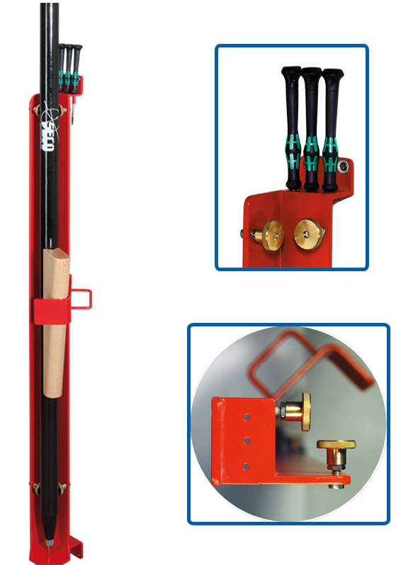
Instructions:

After the really simple assembly on a wall (all you need is an 80 cm or longer construction level or theodolite, a 10-mm open end wrench, a screwdriver, and a hammer drill with a 6-mm masonry bit) and the one time set-up of the station, the poles can be checked in a minimum amount of time.

Place prism pole in the station and press with light pressure against the two pairs of adjustable brass bolts. If the circular bubble is not out of adjustment, just take the pole out - the check-up is finished within seconds.

If the circular bubble should be out of adjustment, fix the prism pole with the wooden wedge in the station. Absolutely reliable orientation of the pole is guaranteed; the foot plate of the station prevents axial moving and avoids damage to the floor covering.

The adjustment of the circular bubble is carried out with the toolset which is stored in the practical tool-holder on top of the device. A little screwdriver as well as two allen keys 2,0 and 2,5 mm are part of the high-quality tool kit.

When adjusting a rod level, a range pole or a prism pole should be used. Just press rod level to the pole and continue as described.

YZ, 2019.1

