
Welcome to myAccess  [Insert application name] is now available for use through myAccess! This means that you can access [Insert application name] anytime, anywhere that you have internet access.  To get started simply logon to myAccess using your zID. On your initial logon you will be prompted to download and install a Citrix Receiver which will enable the service. If you need any help please refer to the myAccess user guides or else contact the IT Service Centre for assistance. | 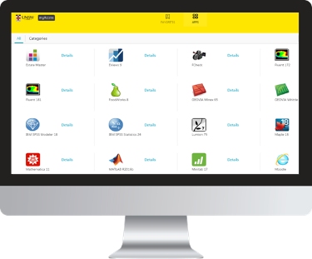
To optimise the performance of myAccess save your datasets to your H: drive.
All UNSW students are automatically allocated storage space on the UNSW File Service. This is known as your Home drive (H: drive). No-one but you can access or even see the data saved in your H: drive. To easily transfer datasets to and from your H: drive use the myAccess File Manager application.
It is important to note that data classified by the UNSW Data Classification Standard as ‘Sensitive’ or ‘Highly Sensitive’ cannot be accessed managed or transmitted via the service.
Please contact the IT Service Centre for any questions or issues.
Kind Regards,

myAccess Team

