Special Disability Trusts project

Easy Read report

What is this report about?

This report is about a project on Special Disability Trusts.

Special Disability Trusts are like a bank account that keeps money safe so a person with disability can pay for things in the future.

Why is this information important?

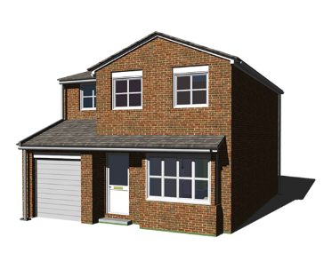Special Disability Trusts are useful for some people.

The money in a Special Disability Trust can be used to pay for housing and care, and some other things.

The information in this report is important because it shows:

The benefits of Special Disability Trusts

What helps people start a Special Disability Trust, and what makes it harder

What changes could make Special Disability Trusts more useful.

Who was involved in the project?

Researchers from the Social Policy Research Centre did the project.

What did the researchers do?

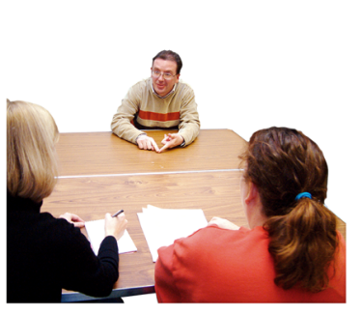The researchers read the legal rules for Special Disability Trusts.

The researchers also talked to people who know about Special Disability Trusts, like lawyers.

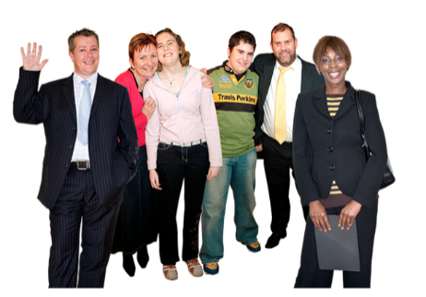Then the researchers talked to some families who had a Special Disability Trust or wanted to set one up.

What do we know about Special Disability Trusts?

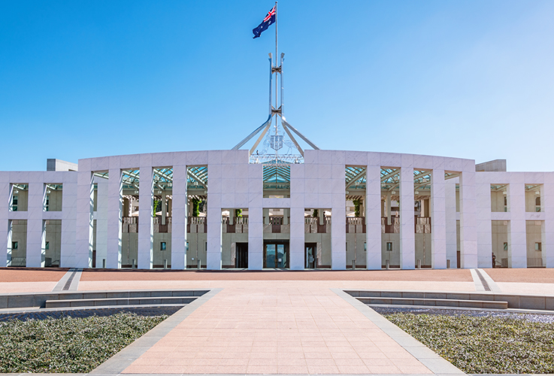Special Disability Trusts were set up by the Government in 2006, so that people with disability can pay for things in the future.

The Government says there are around 2000 Special Disability Trusts in Australia – together they hold about $150 million.

There may be more Trusts. Some families set up Special Disability Trusts in their wills and put money in them later.

We do not know what people use the money in a Special Disability Trust for, because the government keeps that information private.

What is good about Special Disability Trusts?

The good thing about having a Special Disability Trust is that it can have a lot of money in there (up to $700,000) without affecting the Disability Support Pension.

Having a house as part of the Special Disability Trust also means paying less or no stamp duty, land tax and council rates (depending on where you live).

But buying a house is hard, with or without a Special Disability Trust.

What are the barriers to Special Disability Trusts?

People had problems setting up a Special Disability Trust:

The rules are strict

People with disability and their families may not know much about money

People with disability and their families may not have much money to put into a Special Disability Trust

Not many people set up Special Disability Trusts. Not many people or organisations can help set up a Special Disability Trust.

What could help people know more about Special Disability Trusts?

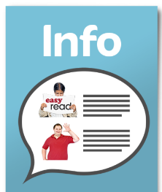People want more information about Special Disability Trusts. Organisations want to know how to set them up.

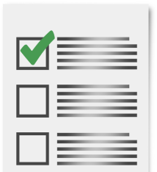People said the government should make the rules easier.



People need other help to find a home that is right for them.

The NDIS could help people with disability find a good home and support them to live in it.

This document was written by Suzanna Poredos and Laura Davy.