Our Voice SA Reaching Out



Final Study Report

[www.arts.unsw.edu.au/sprc](http://www.arts.unsw.edu.au/sprc)



**About this report**

This report is about a project **led by people** with intellectual **disability** for other people with disability.

The project was called **Reaching Out.**

Reaching Out was run by a group called **Our Voice SA**.

This report talks about what Reaching Out **did well**, **what it achieved, and what is needed.**

**About Our Voice SA**

Our Voice SA is a **peer led** **self advocacy** group for people with intellectual disability.

**Peer led** means people with intellectual disability run the group and are part of the group.

**Self advocacy** means having a say about things that matter to you.

Our Voice SA has over **100** active **members**.

Our Voice SA **meets monthly**.

Our Voice SA does **things to help** people with intellectual disability like.

Feel part of their **community**.

Know their **rights**.

**Speak ou**t about the things that matter to them.

Help **services and government** to work better with people with intellectual disability.

**About the Reaching Out Project**

The **Reaching Out Project** wanted to connect to more people with intellectual disability.



The project **was for 3 years**.

The project worked with people with intellectual disability in **South Australia**.

It worked with **people** in the **city** and the **country**.

**About the study**

Part of the Reaching Out project is a **study** called an evaluation.

The study looked at **what the project did well**, and what it achieved.

The study was **done by** **people** at **Flinders University** and **University of New South Wales**.



**How we did the study**

The study used **co design**.

**Co design** means a person with intellectual disability helped with the study.

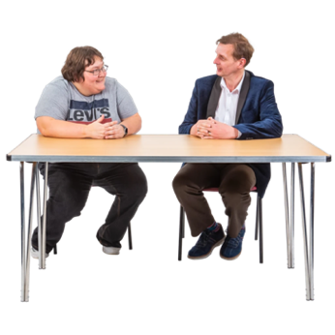

We **talked** to **members** at Our Voice SA.

We **talked** to people who **work** for Our Voice SA.

We **looked** **at** other **information** about Our Voice SA.

**What did Our Voice SA do well?**

Our Voice SA achieved **many great things** in the Reaching Out project like.

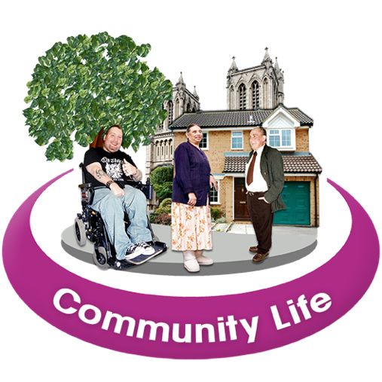

**Worked with services** that run group homes or group employment.



**Set up peer groups** in 9 communities.

**Run workshops** for people living in the country and in the city.

Organised many peer groups.

Peer groupshelp people with disability connect with each other.

Supported people with intellectual disability to become peer leaders.

**What the Reaching Out project achieved**

Over 3 years, Our Voice SA grew **stronger and bigger**.

**Many new members** joined from different services and parts of South Australia.

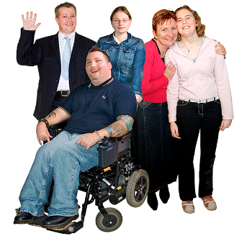People were **better connected** to their peers.

People with disability were more **skilled** and **confident** to speak up.

Some members **became leaders**, and some had paid roles.

The community respected Our Voice SA **for their** **knowledge.**

Our Voice SA **have a** **voice** to speak out for people with intellectual disability.

**Future of Our Voice SA and self advocacy**

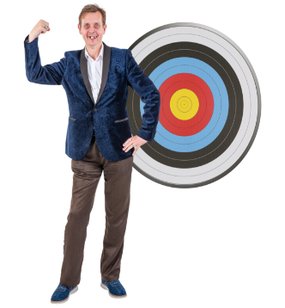Reaching Out achieved **many** **good things** for people with disability in South Australia.

People with disability **connected and learned** about their rights through peer groups.

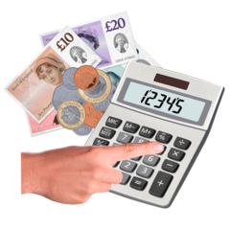Ongoing **funding** for Our Voice SA and self advocacy remains a problem.

Self advocacy groups, like Our Voice SA, **are useful**.

It is **worth spending** money on them.

**More information**



**More information** about the study is on the university website.

You can click this link to find out more:

<https://www.unsw.edu.au/research/sprc/our-projects/our-voice-sa-reaching-out-evaluation>