Support for people with mental illness

www.arts.unsw.edu.au/sprc

Support for people with mental illness

Evaluation of community based mental health programs

Contents | Page
About this report | 3
About the programs | 4
About the evaluation | 5
How we did the evaluation | 6
What the programs did well | 7
How the programs could be better | 9

Report by Christiane Purcal and Bella Bauer

About this report

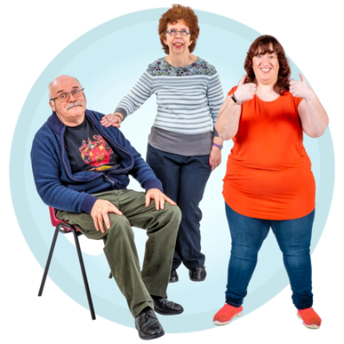 | This report is about programs for people with mental health problems.
HASI  CLS | The programs are called  - Housing and Accommodation Support Initiative  HASI for short.  and  - Community Living Supports  CLS for short.
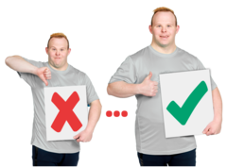 | This report talks about what  - The programs do well  - Could be done better.  This is called an evaluation.
About the programs

 |  | NSW Health pays for the programs.
 |  | The programs have services so people with mental illness can have better lives.
 |  | Support workers help people reach their goals.
The goals could be
- Learn new skills
- Find a job
- Make new friends
- Find other help like drug or alcohol services.

About the evaluation

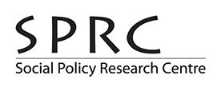 | Researchers from the Social Policy Research Centre did the evaluation of the programs.  SPRC for short.
Researchers are people who find things out by
- Talking to people
- Looking at numbers
- Reading about other research.

 | NSW Health paid for the evaluation.
SPRC started the evaluation in 2017.

The evaluation finished in 2021.

How we did the evaluation

We talked to people with mental health problems who used the programs.

We talked to their families and carers.

We talked to the support services.

We looked at information about the people who used the programs.

We looked at how much the programs cost.

What the programs did well

These are some things that the programs did well.
People in the programs felt better.
People did not go to hospital as much.

Some people found better homes.

People went out more and made new friends.

People did more things that they wanted to do.

People had less to do with police.
The service providers and NSW Health worked well together.

The programs were cost effective.

Hospitals and police spent less money.

How the programs could be better

These are things that the programs could do better.

They should always let people choose
- Their goals
- What they want to do.
They should do more with people to help their physical health.

Physical health is keeping your body well.
More people who leave prison should be able to use the programs.

They should listen more to staff who

Are Aboriginal

Are from different cultures

Have a mental illness themselves.

They should work more with other local services.
If you want more information about the evaluation click on the website link here.

